
Department of Computer and Communication Engineering

LAB REPORT
Experiment No : 03
Experiment Name : Drawing Basic 2D Shapes using WinBGIm Graphics Library

Course Title : Computer Animation and Game Development Sessional
Course Code : CCE - 3606

Submitted By
Name : Kazi Sultana Sunehra
ID No : E231413
Semester : 5th
Section : 5AF

Date of Experiment: 29. 09. 2025
Remark
Date of Submission: 06. 10. 2025

Submitted To
Md. Warid Bin Azad
Adjunct Faculty, Dept. of CCE, IIUC

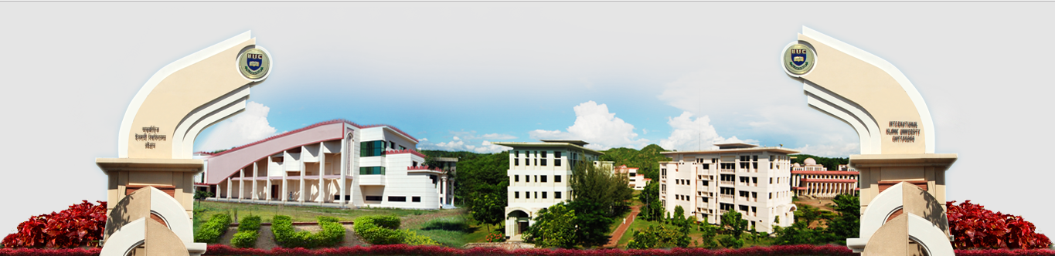
Experiment No: 03

Experiment Name: Drawing Basic 2D Shapes using WinBGIm Graphics Library

Lab Task – 01: Draw a kite.
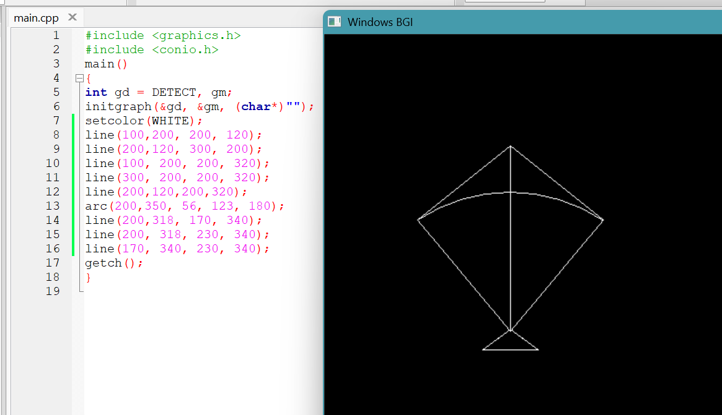
Fig – 01: Source Code and Output for Lab Task – 01

Lab Task – 02: Draw a pen
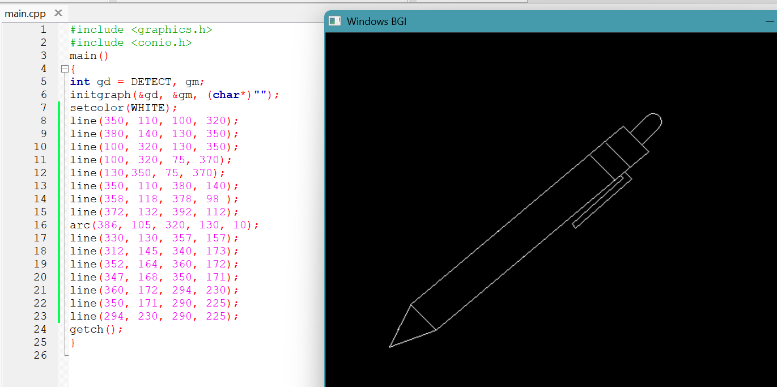
Fig – 02: Source Code and Output for Lab Task – 02

Lab Task – 03: Draw an ice-cream with colours.
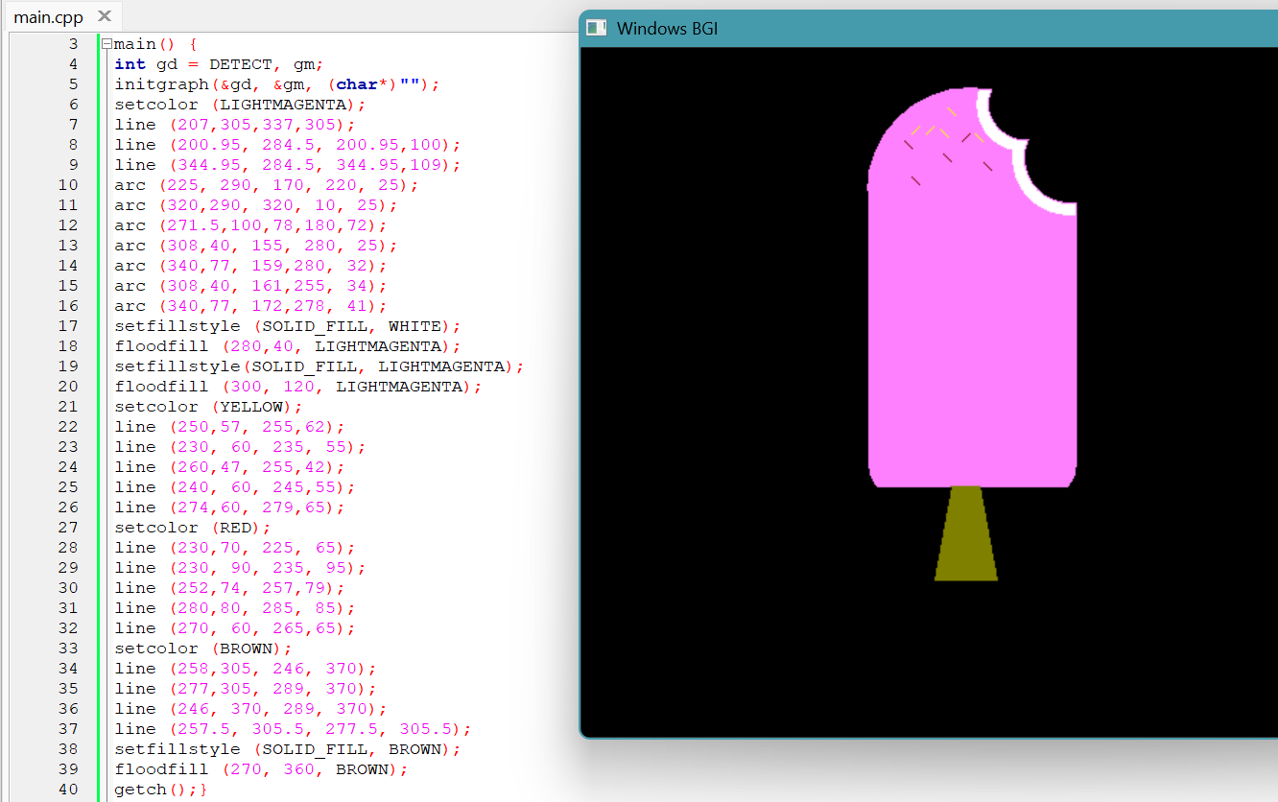
Fig – 03: Source Code and Output for Lab Task – 03

Lab Task – 04: Draw the Italian flag with colours.
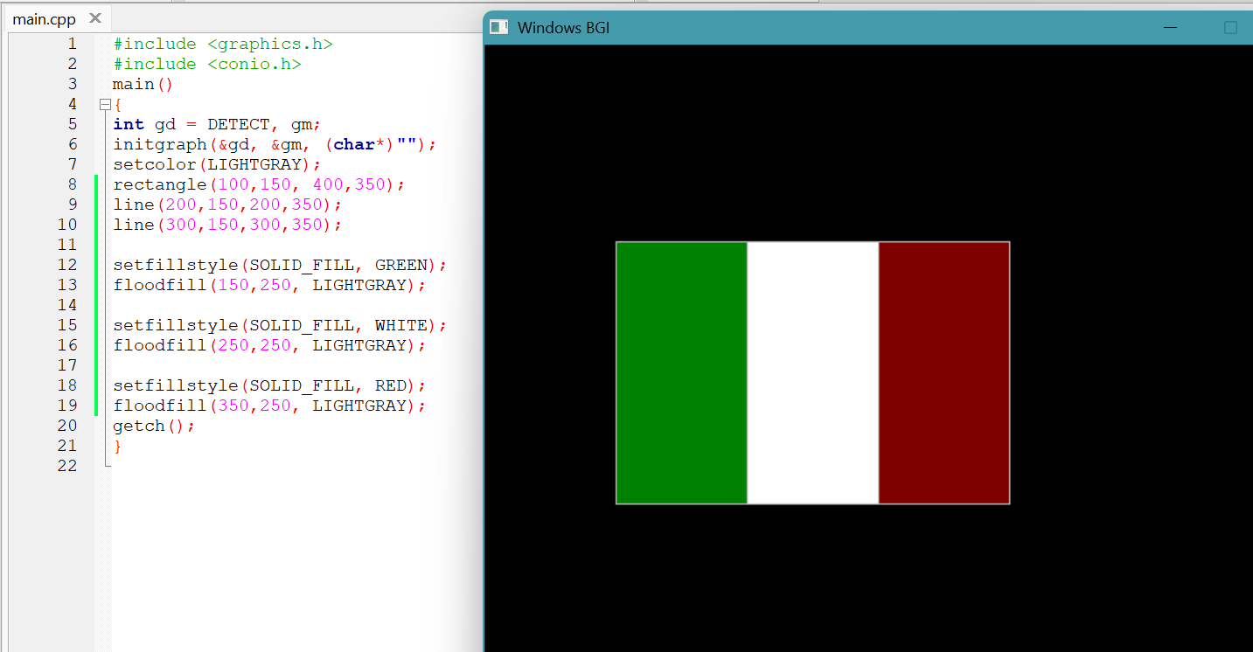
Fig – 04: Source Code and Output for Lab Task – 04

Lab Task – 05: Draw a car with colours.
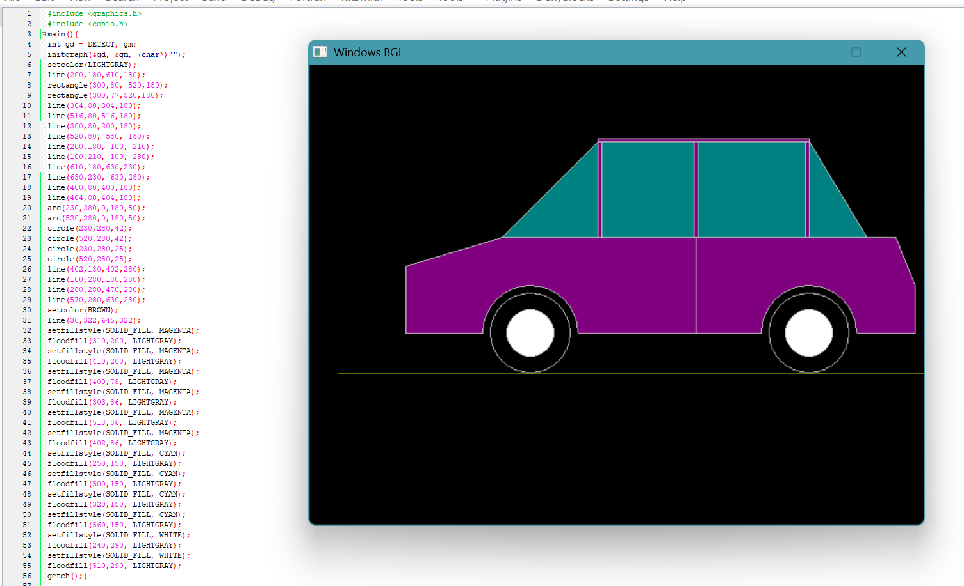
Fig – 05: Source Code and Output for Lab Task – 05

Lab Task – 06: Draw a bottle with colours.
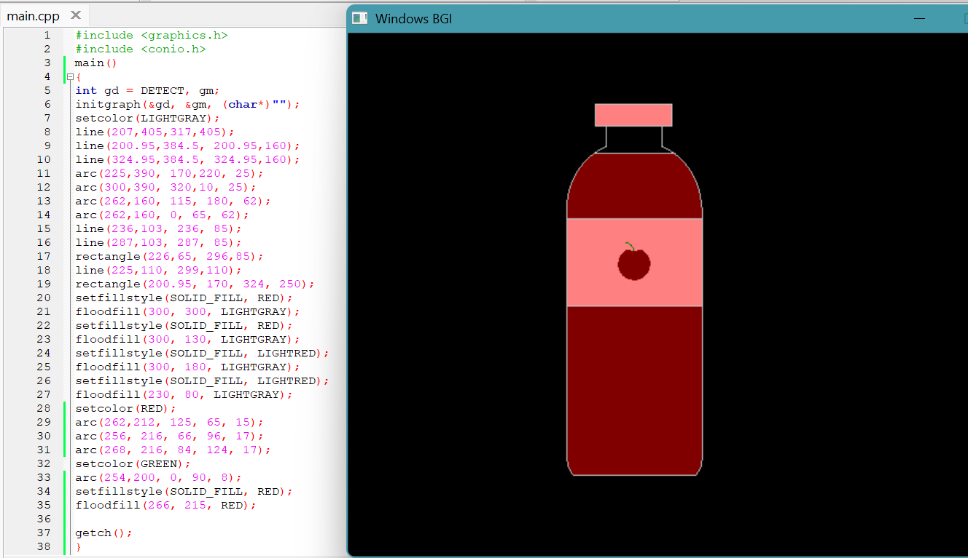
Fig – 06: Source Code and Output for Lab Task – 06

